Here several guidance that all you guys able to utilize DataProvider. Everyone who familiar in how to query or perform data manipulation SQL using store procedure is suitable to use it.

First of all, please have a look on the following image

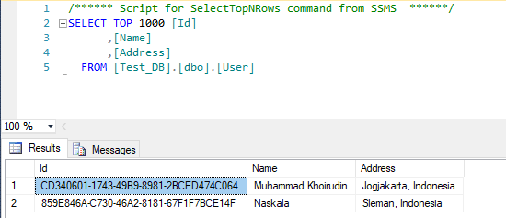

As per image above, I only use the simple table contains Id (uniqueidentifier), Name, Address (varchar). But if you will, you simply restore my database backup that caller Test_DB.

Great. Let’s get started.

1. **Get**

It uses to get single data / single column in database table. All you guys can get string, integer, boolean, datetime etc.

|  |
| --- |
| public object Get(GenericCommand command)  {  return db.Get(command.CommandText, command.InputParameters);  } |

Above code is called as API. Once all of you have already create it, then create store procedure & client code to call the API.

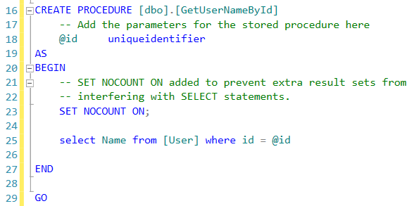

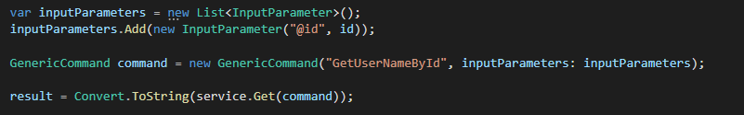

Above code is sample how to call data provider with passing input parameter for store procedure.

1. **Select**

It uses to retrieve multiple columns or and rows both from single table or join table

|  |
| --- |
| public DataTable Select(GenericCommand command)  {  return db.Select(command.CommandText, command.InputParameters);  } |

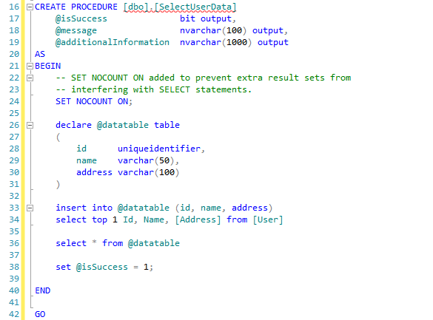



Above code is sample how to call data provider without passing input parameter for store procedure.

Notes : For Get and Select API, we only passing the command text (store procedure name) and input parameter if necessary.

1. **Insert, Update & Delete**

The database operation unless query able to use this API. By default data provider will provide you 3 output parameter such as “IsSuccess as boolean”, “Message as string” & “AdditionalInformation as string”.

1. Is Success will inform you that the operation is succeed or not, thus it only has true or false value
2. Message will inform you about specific message in case the error occurs. So, you able to trace the issue as soon as possible
3. Additional Information , in my opinion, I use this param to store the data related. For example if we don’t find the particular data after selecting with where (id) clause suppose, then I shall store id data to additional information

|  |
| --- |
| public MessageStatus Save(GenericCommand command)  {  return db.Save(command.CommandText, command.InputParameters, command.OutputParameters, command.ParameterStatus, command.DoesUseTransaction);  } |

Example 1

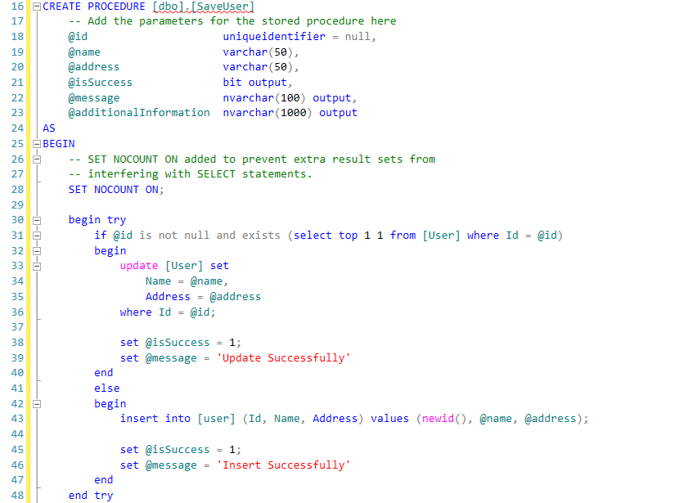

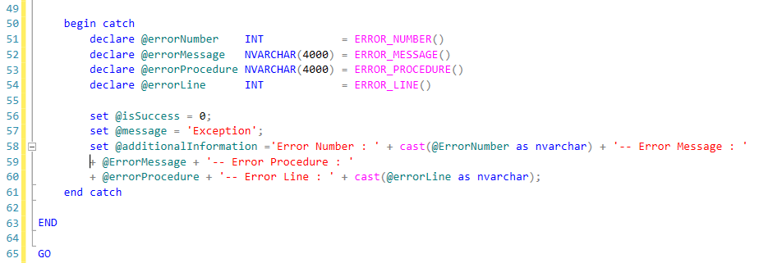

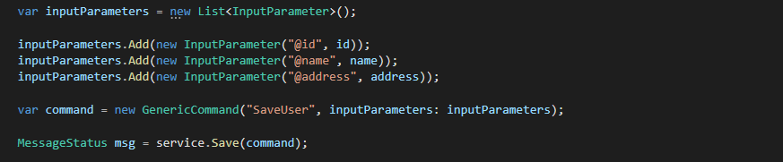

---------------------------------------------------------------------------------------------------------------------------------------

Example 2

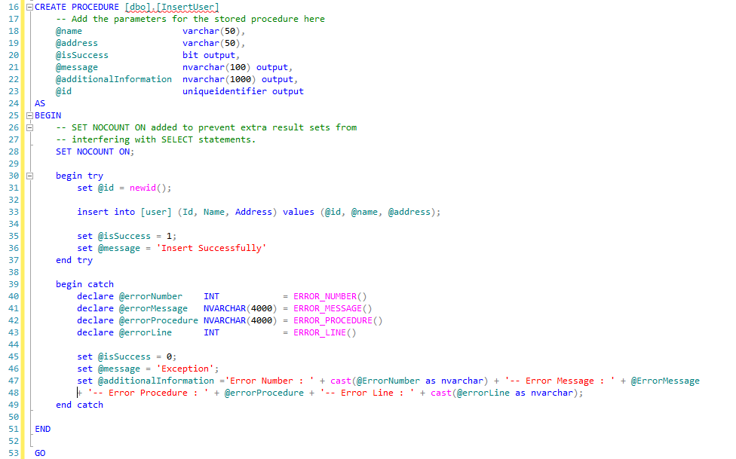

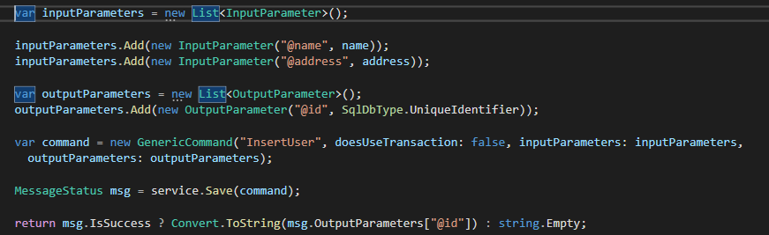

Above code, I show you to replace default data for generic command.

Notes : For Insert, Update & Delete, By default we will send several data in Generic Command, such as command text (store procedure name), input parameter (by default null), output parameter (by default null) & transaction (by default is true / use DB transaction).

1. Operation Return Data Table

If all you guys perform query or insert, update & delete data that need to return data table as part of result. For example if you have multiple data that will be bulk delete. It can be possible particular data won’t be succeed, and the other is succeed. In order to store information for each row we may use temporary table in our Store procedure.

Here the API

|  |
| --- |
| public MessageResult<DataTable> ReturnDataTable(GenericCommand command)  {  return db.ReturnDataTable(command.CommandText, command.InputParameters, command.OutputParameters, command.ParameterStatus, command.DoesUseTransaction);  } |

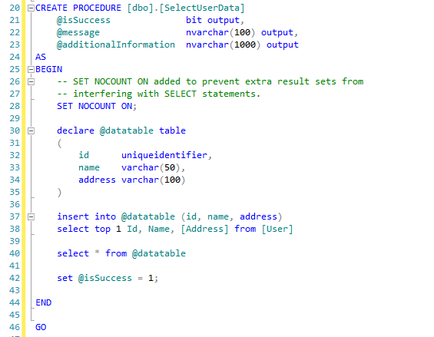

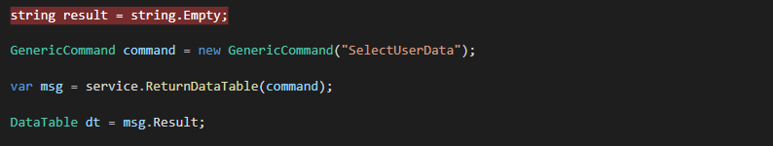

Notes : this data provider will return datatable, isSuccess, Message & AdditionalInformation. Please keep in mind that, the data table will have the value if isSuccess equals true, unless if I’m not mistaken the datatable will be null